Task 4b Review:
In this evaluation I will outline how the developed solution meets the system and user requirements as well as suggesting improvements.

The existing code provided allows user to select a flight route and show the trends for passenger numbers over a given time period.

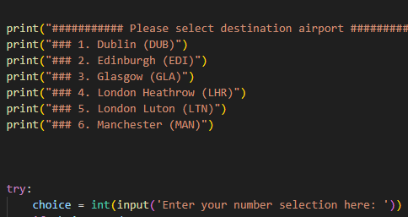
Selecting route:

The route menu will provide the user with a list of options and will run the corresponding functions based on the input from user.

The menu’s output is meaningful and easy to use as to select, the user only needs to enter a corresponding number for each option.
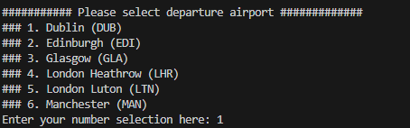
The code handles user errors such as entering a number out of menu range or input that is not a number or entering nothing at all well.

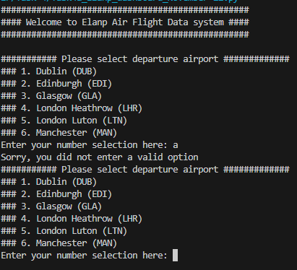
The main loop will continue running until the input the user gives is valid.

Selecting Time Period to Show
To select a period to search for in the data, the program will provide the user a space to input the number of days to search for in the data. If the user enters an invalid value, the program will continue to prompt the user until valid input is given.

The above code will print a message asking the user to see how many days of data they would like to see and then gives a space for them to input a value.
The functionality of this code is simple because it only requires the user to enter a single value and displays instructions in a clear and meaningful way.

Ease of use
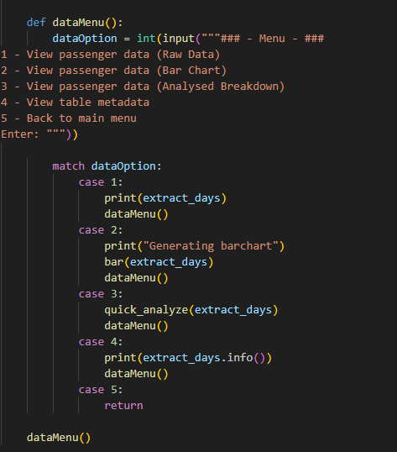
After user enters search criteria with destination, departure and number of days to show, the program then outputs a menu with options on how to display the data.
The above code simply displays a menu presenting all choices in a clear and meaningful way. The user only has to enter a single digit in order to execute the function they wish to, the code can handle user errors such as invalid input or not entering anything at all.

Displaying meaningful data
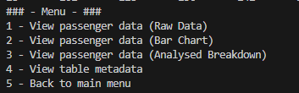
The user can choose to output data as ether CSV raw data, bar chart, further analyse data or get table metadata.

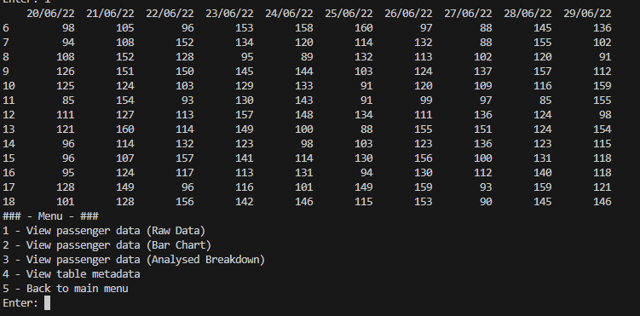

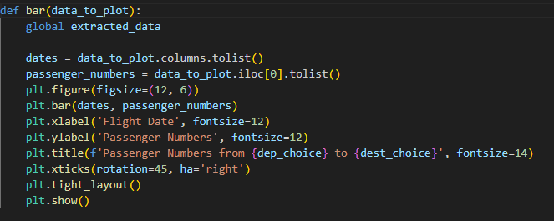


The above code generates a bar chart using the values extracted from the tabler in order to provide the user with a clear, easy to read and meaningul way to view the data.

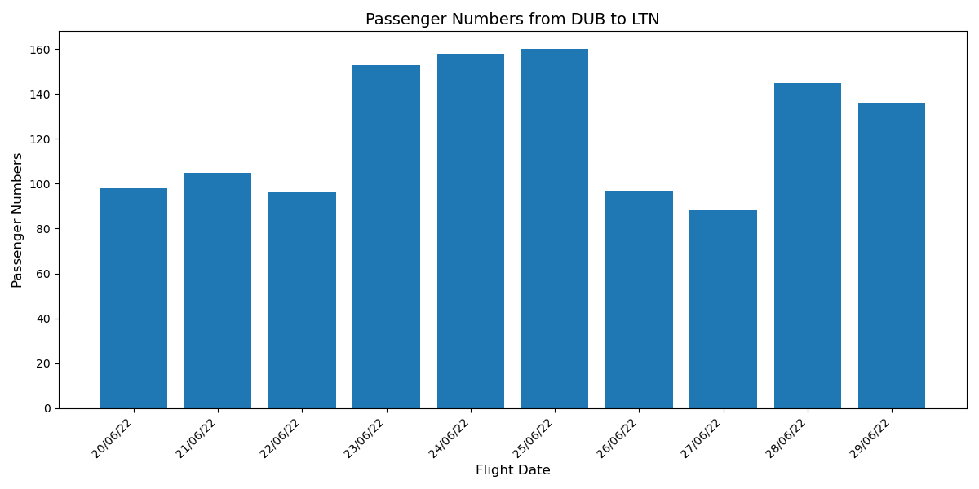

This is enhanced by the use of vibrant colouring, a clear title for the graph detailing what it is shown and clear easy to read lables on the x and y axis allowing for quick visual representation of data.

The solution must be secure
The solution minimally uses global variables with only one being used throughout the program in to keep it running. This could be updated using a wrapper function instead of a loop to improve security of the solution.
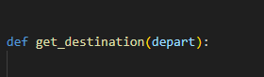
Only one global variable is used throughout the program. When data is needed, instead of using global variables data is passed into functions using parameters. (as show in screenshot below)

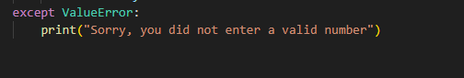
Error messages outputted to the user do not display any program data and instead output a clear general description of the error that occurred and what caused it. For example: Value error, must be an integer!

Data Analysis Menu
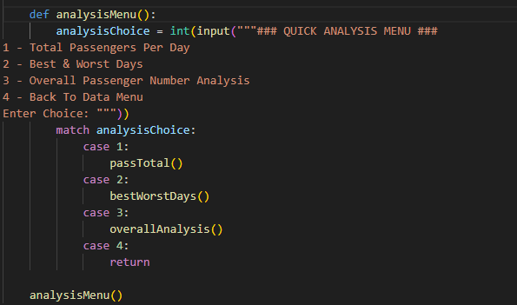
The users can use bult in analytic features to analyse the data extracted from the table, this includes total passengers per day, best and worst days for profit, overall passenger count.
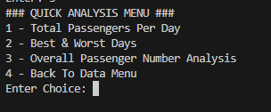
The code above displays a simple menu where the user must input a single value to execute the function they wish. The options are displayed in a clear and easy to read format.

The departure airport which has the largest number of passengers over time
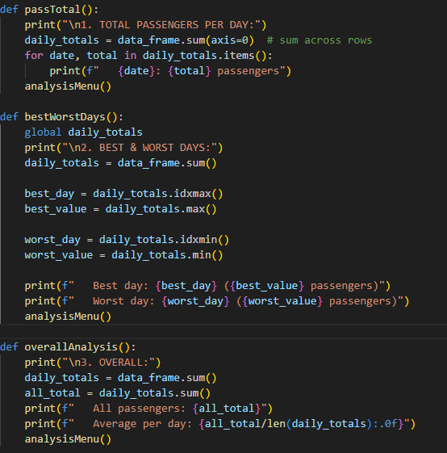
The above code shows the functions that are executed by the choices in the previously shown menu.
The program allows users to complete a range of analytical operations on the data quickly and easily outputting results in a meaningful format

Identify trends and patterns over time for AM and PM flights for two selected routes
With the dataset and solution provide it is not possible to implement the addition of trend identification for AM and PM flights. This is because the data given only shows flights separated based from day not time.
With the introduction of new data, it would be possible to implement this trend identification easily as the code is well structured and maintainable.

Future Improvements

Hardcoded Values
One improvement that could be made is in the main aspect departure and destination menu, the values are hardcoded therefore it does not allow for flexible route adjustment, it could be improved to fetch the destinations and departures from the file instead of being hardcoded therefore allowing for greater flexibility, as if the routes change they will automatically update from the file instead of having to go back and change the code therefore increasing the maintainability of the program

AM / PM Trend Identification
Another improvement that could be made to the program is it mentions in the client brief that the program should identify patterns in AM and PM flights, although the developed program includes many analytical features it does not meet these criteria as it is not able to separate the data into AM and PM flights.

Data Storage Method
Another improvement that could be made is to the data storage function of this system, currently the flight data is stored in a CSV file, while this has high cross combability there are more efficient, secure and organised formats to store this data in such as using an organised database file.

4 - GUI
One more change that could be added to the system in order to improve is through the use of a Graphical User Interface (GUI) to allow users to easily navigate throughout the system menus and features more easily, this is because currently this system utilizes a Command Line Interface (CLI) which is not very user focused and may be more complicated to navigate.

Conclusion

